**INTRODUCTION**

**PROJECT TITLE**

**COOK BOOK: YOUR VIRTUAL KITCHEN ASSISTANT**

**TEAM**

**TEAM LEADER: R. NITHYA BHAVANI (CODE EXECUTION AND VOICE OVER )**

TEAM MEMBER: B. VIJAYA BHATHURI (DOCUMENTATION)

TEAM MEMBER: M. SNEHA (GIT HUB)

TEAM MEMBER: B. RASIKA ( CODE EXECUTION )

TEAM MEMBER: S. NIVETHA ( CODE EXECUTION )

# PROJECT OVERVIEW

**Purpose:**

Cook Book is a dynamic web application designed to revolutionize recipe discovery, organization, and creation. It caters to both home cooks and professional chefs, providing a seamless user experience with powerful features like advanced search, recipe categorization, and interactive recipe pages.

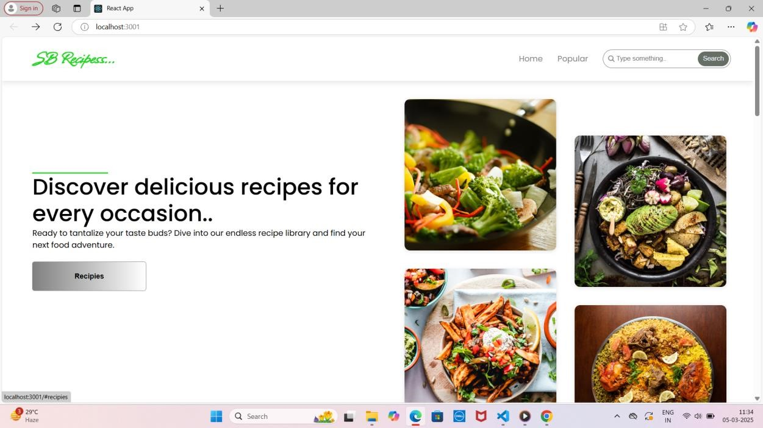

**DESCRIPTION :**

Cook Book is a React-based web application designed to make cooking effortless and enjoyable. It allows users to explore a vast collection of recipes, save their Favorite dishes, and organize ingredients efficiently. With smart search functionality, step-by-step cooking instructions, and personalized meal recommendations, Cook Book caters to both beginners and experienced chefs. The app also features an intuitive user interface, meal-planning tools, and grocery list integration to streamline the cooking process. Whether you're looking for quick weeknight dinners or gourmet creations, Cook Book is your perfect kitchen companion.

Beyond just a recipe manager, Cook Book offers smart features like personalized meal recommendations, ingredient substitutions, and grocery list generation. The app helps users optimize their kitchen experience by suggesting meals based on available ingredients, dietary preferences, and cooking time. With built-in search functionality and filter options, finding the perfect recipe is quick and hassle-free.

Cook Book is designed to be a seamless and interactive cooking assistant for users of all skill levels. Its responsive design ensures accessibility across devices, allowing users to browse and follow recipes from their desktop, tablet, or mobile phone. Whether planning meals for the week or trying out a new dish, Cook Book is your go-to kitchen companion, making cooking more enjoyable, efficient, and stress-free.

From hearty breakfasts to indulgent desserts, each recipe is crafted with love, using simple ingredients that bring people together. With step-by-step instructions, cooking tips, and vibrant photos, *Flavours of Home* makes it easy to create unforgettable meals for family and friends.

Cooking is more than just preparing food—it’s an experience that brings people together. *The Ultimate Cookbook* is your go-to guide for creating mouth watering meals, whether you're cooking for a cozy family dinner or a festive gathering. With a diverse collection of recipes ranging from quick and easy weekday meals to impressive dishes for special occasions, this book is designed to inspire both beginners and seasoned cooks alike. Each recipe is carefully crafted with simple ingredients, step-by-step instructions, and helpful tips to ensure success in the kitchen.

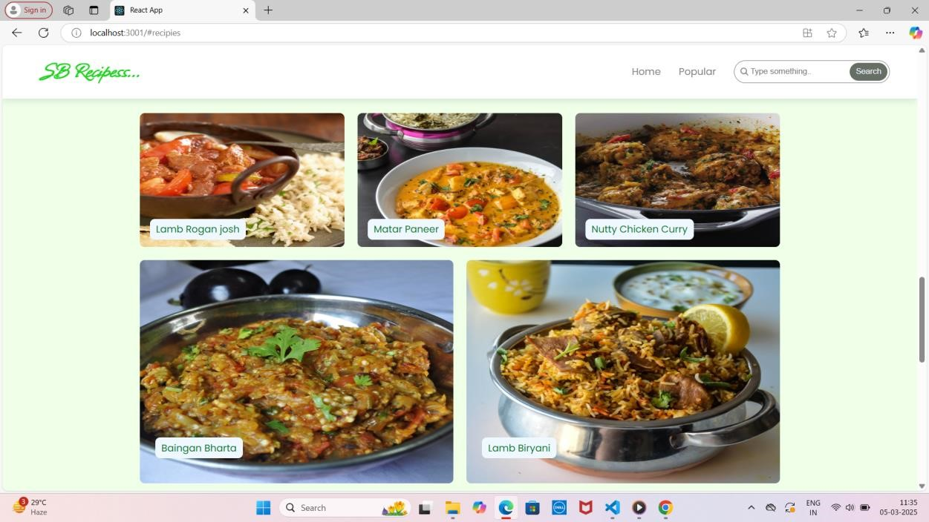

**SCENARIO: A Busy Professional Planning a Healthy Dinner**

Emma is a busy marketing executive who loves cooking but struggles to plan meals after long work hours. One evening, she opens **Cook Book: Your Virtual Kitchen Assistant** on her phone, looking for a quick and healthy dinner idea. She uses the **smart search feature** to filter recipes by “under 30 minutes” and “high-protein.” Within seconds, she finds a **grilled salmon with quinoa salad** recipe that fits her preferences.

Before heading to the kitchen, Emma checks her pantry and realizes she’s out of quinoa. Luckily, Cook Book suggests **alternative ingredients**, recommending brown rice as a substitute. She updates her grocery list within the app and makes a mental note to pick up quinoa on her next shopping trip. As she cooks, she follows the **step-by-step instructions** on her tablet, using the app’s built-in **timer and measurement converter** to ensure accuracy.

After enjoying her delicious meal, Emma saves the recipe to her “Quick & Healthy” collection for future reference. She also rates the dish and leaves a note about adding extra lemon juice for more flavour. Thanks to Cook Book, Emma has not only prepared a nutritious meal with ease but has also streamlined her meal-planning process—making healthy eating more convenient despite her busy schedule.

**ARCHITECTURE:**

**COMPONENT STRUCTURE:**

**Navbar Component:** Handles site-wide navigation.

**Hero Section**: Showcases the app’s purpose with call-to-action buttons.

**Category & Recipe Components:** Fetch and display recipe categories and details.

**Trending Dishes & Popular Categories:** Dynamically load content via API calls.

**Newsletter Component:** Allows users to subscribe to newsletters.

**State Management**:

State management is handled using React’s use State and use Effect hooks. Data is fetched and updated through Axios API calls, ensuring real-time updates.

**Routing:**

React Router Dom is used to manage page navigation:

/ → Home Page

/category/:id → Category-specific recipes

/recipe/:id → Detailed recipe view

**PROJECT GOALS AND OBJECTIVES:**

* **Simplify Meal Preparation** – Provide an intuitive and user-friendly platform that helps users explore, organize, and follow recipes effortlessly.
* **Enhance Cooking Experience** – Offer smart features such as ingredient substitutions, grocery list integration, and step-by-step instructions to make cooking more efficient.
* **Promote Healthy and Personalized Eating** – Allow users to filter recipes based on dietary preferences, available ingredients, and nutritional needs.
* **Ensure Accessibility and Convenience** – Design a responsive React application that works seamlessly across desktop, tablet, and mobile devices.
* **Encourage User Engagement** – Enable users to save favorite recipes, leave ratings, add personal notes, and share meal ideas with others.
* Develop a **React-based web application** with a clean and responsive UI.
* Implement a **dynamic recipe database** with search and filter functionalities.
* Integrate a **smart grocery list** feature to help users manage ingredients efficiently.
* Provide **step-by-step cooking guidance** with timers, measurement conversions, and voice-assisted instructions.
* Enable **personalized meal recommendations** based on user preferences, cooking habits, and dietary restrictions.
* Ensure **data storage and synchronization**, allowing users to access their saved recipes and lists across multiple devices.
* Maintain a **scalable and secure backend** to support future feature expansions, such as user-generated recipes and community interactions.

**FEATURES OF COOKBOOKS:**

* **Recipe Discovery & Search** – Explore a vast collection of recipes with advanced search and filter options based on cuisine, ingredients, cooking time, and dietary preferences.
* **Personalized Recipe Recommendations** – Get AI-powered meal suggestions tailored to your tastes, past selections, and available ingredients.
* **Grocery List Integration** – Automatically generate shopping lists based on selected recipes and keep track of pantry items.
* **Step-by-Step Cooking Instructions** – Follow detailed, easy-to-read cooking guides with timers, images, and video tutorials for better accuracy.
* **Ingredient Substitution Suggestions** – Receive smart alternatives when missing ingredients to help adapt recipes without extra shopping.
* **Meal Planning & Scheduling** – Plan meals for the week by organizing recipes into a built-in meal calendar.
* **User Accounts & Recipe Collections** – Save, categorize, and manage your favourite recipes in personalized collections.
* **Nutritional Information & Dietary Filters** – View calorie counts and macronutrient details while filtering recipes based on dietary needs (vegan, keto, gluten-free, etc.).
* **Interactive Cooking Tools** – Use built-in timers, measurement converters, and voice assisted guidance for a seamless cooking experience.
* **Cross-Device Accessibility** – Access saved recipes, meal plans ,and grocery lists on any device, ensuring convenience whether at home or on the go.

**PROJECT STRUCTURE:**

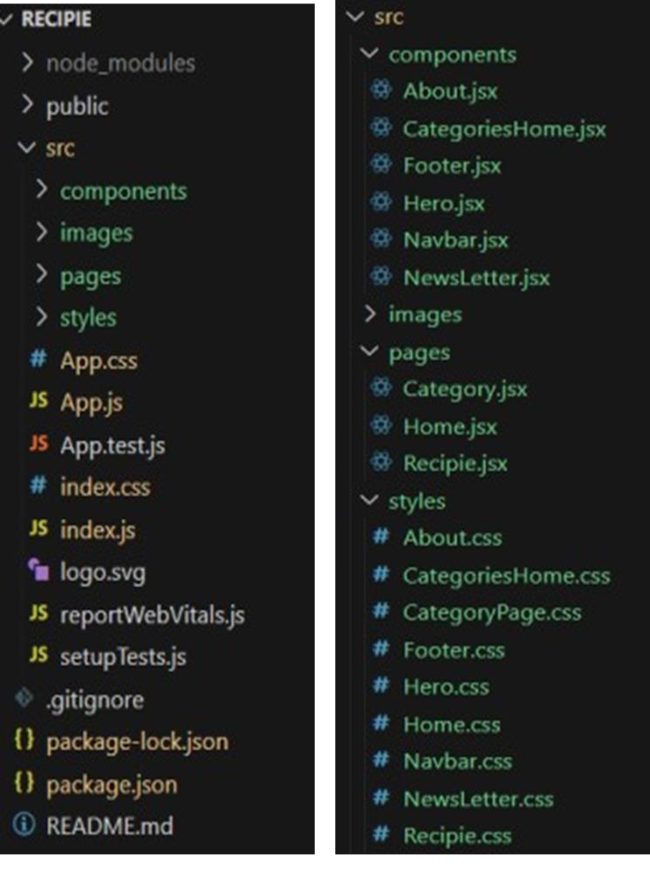

In this project, we’ve split the files into 3 major folders, *Components, Pages and Styles.* In the pages folder, we store the files that acts as pages at different URL’s in the application. The components folder stores all the files, that returns the small components in the application. All the styling CSS files will be stored in the styles folder.

# SETUP INSTRUCTIONS

**Prerequisites:**

**Node.js & npm :** For package management and running the development server.

**React.js:** JavaScript library for building the UI.

**Code Editor:** Visual Studio Code, WebStorm, or your preferred IDE.

**INSTALLATION:**

1. **Clone the Repository:**

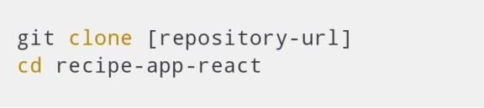

1. **Install Dependencies:**

npm install

**3.Start the Development Server:**

npm start

**4.Access the Application:**

Open your browser and navigate to**:**

[**http://localhost:3000**](http://localhost:3000/)

# Running the Application

Start the app locally:

npm start

It will automatically open in your default browser at:

http://localhost:3000

# Component Documentation

**Key Components:**

**Navbar**: Manages site navigation.

**Hero Section**: Welcomes users and highlights app features.

**Recipe List**: Displays a list of recipes within a category.

**Recipe Detail:** Shows full recipe details, including ingredients, instructions, and a tutorial video.

**Newsletter Signup:** Collects user emails for subscriptions.

**Reusable Components:**

**Button**: Customizable button with variant options.

**Card**: Displays recipe previews with images and titles.

# State Management

**Global State:** Managed via React’s Context API to store user preferences and favorites.

**Local State:** Managed with useState hooks for component-level interactions, like toggling recipe details or handling form inputs.

# User Interface

The UI is designed for simplicity and efficiency:

**Homepage**: Showcases featured categories and trending dishes.

**Category Page:** Lists all recipes in a selected category.

**Recipe Page:** Displays full recipe details with images, ingredients, instructions, and a video tutorial.

# Styling

**CSS Frameworks:**

**Tailwind CSS:** For modern, responsive design.

**React Icons:** For intuitive iconography.

**Custom CSS:** For unique component styling.

**Theming**:

The app follows a light and dark theme switcher to enhance user experience.

# Testing

**Testing Strategy:**

**Unit Testing**: Using Jest for testing individual components.

**Integration Testing:** Using React Testing Library for testing component interactions.

**End-to-End Testing:** Using Cypress for simulating user flows.

**Code Coverage:**

Ensure at least 80% coverage for critical components.

Use tools like Istanbul for generating coverage reports.

Screenshots or Dem

Screenshots

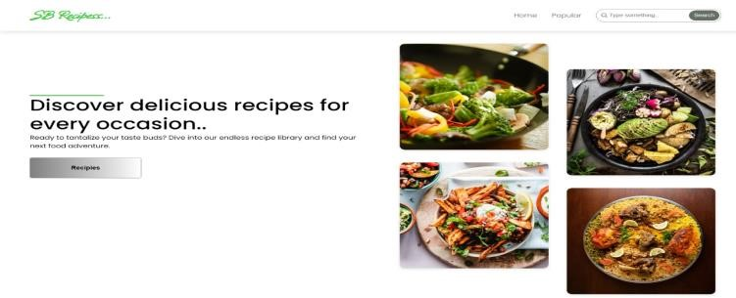

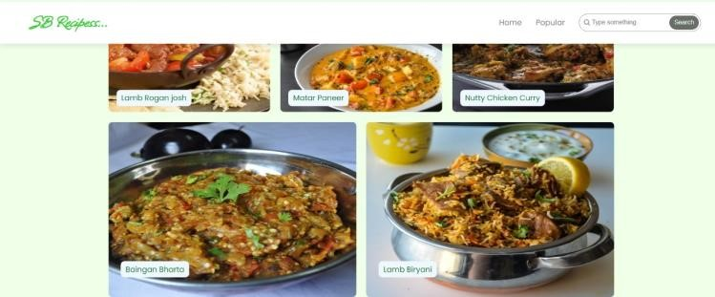

**Drive link:**

[**https://drive.google.com/drive/folders/1s9R2xmgUwOuaXqHRUNsFD5LQOBIkr?us**](https://drive.google.com/drive/folders/1s9R2xmgUwOuaXqHRUNsFD5LQOBIkr?us)

**p=drivelink**

**Video link:**

[**https://drive.google.com/file/d/1n_nABLNCFeQOxXOYuM5RwM_ROGMsRTG/view?usp=drivesdk**](https://drive.google.com/file/d/1n_nABLNCFeQOxXOYuM5RwM_ROGMsRTG/view?usp=drivesdk)

# Known Issues

API rate limits might affect data loading.

Missing images for certain recipes from the MealsDB API.

# Future Enhancements

**User Authentication**: Save and manage personal recipe collections.

**Custom Recipe Uploads**: Let users contribute their own recipes.

**Meal Planning Feature:** Generate weekly meal plans based on user preferences.

**Ingredient Substitutions:** Suggest alternatives for unavailable ingredients.

**Voice-Guided Cooking:** Step-by-step audio guidance for hands-free cooking.